

**INSTALLATION MANUAL**

### **Table of Contents**

### **Applicable Version**………………..…....……………………………….……………………….1

### **Installation**....………………………….……….……………………………………………………1

### **Configuring Ingenico**………………..……………………………………………………………3

### **Applicable versions**

|  |  |
| --- | --- |
| **Applications** | **Versions** |
| PHP | 7x |
| WHMCS | 8x |

### **Installation & Upgrade**

Please follow the given steps to install and run the Ingenico Payment Gateway module

1. Copy all files/folders recursively to WHMCS installation directory

2. Go to System Settings >Payment Gateways > All Payment Gateways and install the Ingenico gateway extension.



**Update Plugin**

1. Deactivate Ingenico and delete the existing ingenico files

2. After the successful uninstallation, install the updated Ingenico package as mentioned above.

### **Configuring Ingenico**

1. Go-to Manage Existing Gateways
2. Scroll down. You will see ingenico, Edit it
3. Configure it as below:

|  |  |
| --- | --- |
| **Column Name** | **Description** |
| Name | ingenico |
| Merchant Code | Enter Merchant Code |
| Salt | Enter Salt. |
| Payment Type | For Test mode Select ‘Test’ and for Live mode select ‘Live’ |
| Merchant Scheme Code | Enter Scheme Code |

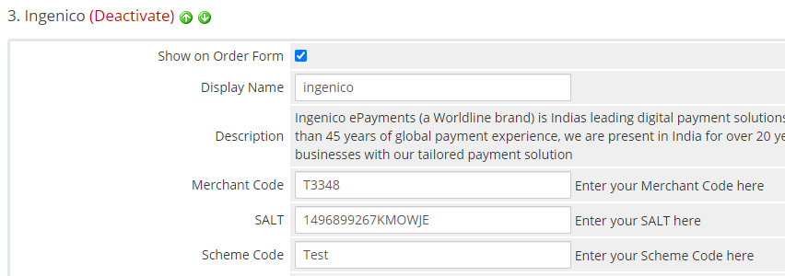

1. Now click on “Save Changes”.
2. Ingenico Payment Gateway is now configured & ready to use.

**Advanced Configuration**

There are also some advanced configuration options you may consider as shown below:

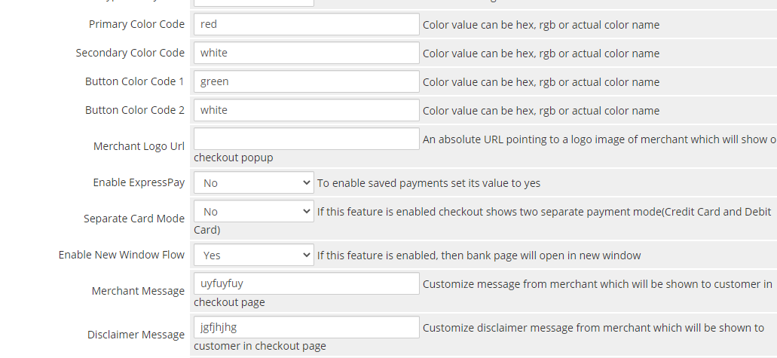

## **Features List**

### **Dual verification of response**

We are validating responses with a hash value and call again Payment Gateway for dual verification from the payment gateway before updating to the order status.

### 

### **Reconciliation**

Merchants can update the pending status of the order automatically if the payments are successful. This page can be found under Manage Existing Gateways>ingenico->Scroll down>Reconciliation

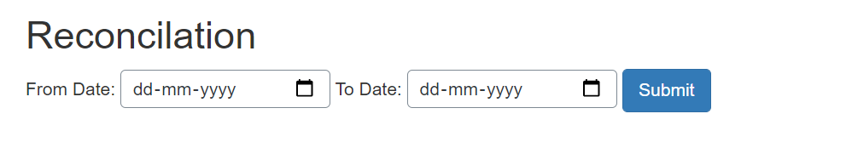

### **Logs request and response**

Daily new file creates for the logs request and response from the server for future reference.

### **S2S Verification**

If we do not receive any response from the payment gateway then after 30 mins, we will get a response from the server and based on the response it will update order status.

To configure S2S URL, contact prod team.

S2S url format : hostname/modules/gateways/callback/ingenico.php?action=s2sverification&msg=

S2S url example:

http://example.com/modules/gateways/callback/ingenico.php?action=s2sverification&msg=

### **MCG**

It supports the multi currency like USD, GBP, SGD and a lot more.

### **Offline Verification**

Merchants can verify the status of their payment by using the Payment Verification page. The payment verification page can be found under Manage Existing Gateways>ingenico->Scroll down>Offline Verification

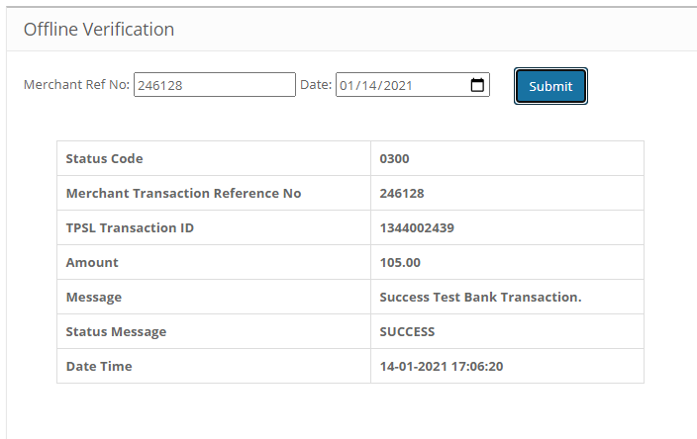

### 

### **Refund**

Merchants should be able to process the refund online for the order whose payment has been done via Ingenico.

To refund an order go to billing>invoices>select the invoice>click on refund tab

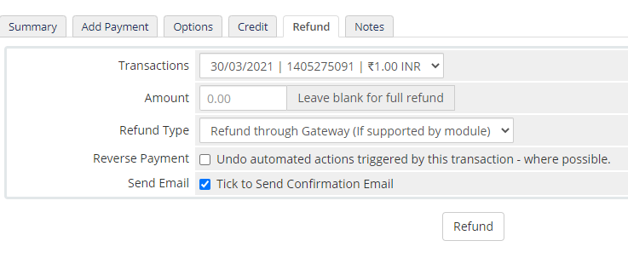

### **Embed Payment Gateway**

After enabling this setting, payment gateway displays like embedded on the page instead of pop-up so user experience would be good.

## **Documentation link**

[**https://www.tecprocesssolution.com/proto/p2m/client/salt-based-documentation.htm#online**](https://www.tecprocesssolution.com/proto/p2m/client/salt-based-documentation.htm#online)